**📚 Library Management System**

**✨ Comprehensive Project Report**

**1. Introduction**

The Library Management System (LMS) is a full-stack, web-based application aimed at simplifying the management of a library's operations. From book management to user handling and fine tracking, the system automates traditional manual tasks, reducing human errors and increasing efficiency.

Built using the Django web framework, LMS offers a scalable backend, a clean and modern frontend styled using Tailwind CSS, and a robust database integration using PostgreSQL (or SQLite in development environments). The platform supports both user-level and admin-level functionalities, ensuring a seamless experience for every stakeholder involved.

This project was designed with real-world library environments in mind—schools, colleges, and public libraries—offering a practical and deployable solution.

2. Core Features and Functionalities

👥 User Registration & Login

* Secure sign-up and login system using Django’s built-in authentication module.
* Separate views and permissions for admin users and regular users.
* Password hashing and CSRF protection for security.

**📚 Book Management**

* Admins can add, edit, delete, and view book records.
* Book details include title, author, ISBN, category, publication year, and availability status.
* Books can be filtered/searched for easy access.

**👤 Member Management**

* Admins can manage library members including:
  + Creating new member records.
  + Updating member information.
  + Deleting inactive or invalid members.
  + Viewing member details.

**📖 Loan Management**

* Allows books to be issued to members with defined borrowing limits and return periods.
* Tracks:
  + Borrowed books.
  + Return dates.
  + Overdue items.

**💵 Fine Management**

* Automatically calculates fines based on due dates.
* Admin can update fine status (paid/unpaid).
* Fine details visible in user dashboards for transparency.

**📊 Dashboard (Role-Based)**

* User Dashboard:
  + Current borrowed books.
  + Due dates.
  + Outstanding fines.
* Admin Dashboard:
  + Quick access to all books, members, loans, and fines.
  + Summary cards for overdue items, active members, and statistics.

**📱 Responsive UI**

* Built with Tailwind CSS for responsiveness.
* Works across desktops, tablets, and mobile phones.
* Consistent user experience across all devices.

3. System Architecture

🔧 Technology Stack

| **Component** | **Technology** |
| --- | --- |
| **Frontend** | **HTML + Tailwind CSS** |
| **Backend** | **Django (Python)** |
| **Database** | **PostgreSQL / SQLite** |
| **Authentication** | **Django Auth System** |

🧭 Architecture Flow Diagram

[User Interface] → [Django Views & Templates] → [Django ORM] → [Database]

💡 Explanation

* Users interact with HTML templates rendered via Django views.
* Views handle business logic and data flow using models.
* Models interact with the database using Django’s ORM for CRUD operations.
* Authentication system ensures secure access to features based on roles.

4. Screenshots (UI Highlights)

* 🔐 Login Page: Secure entry point for users/admins.
* 🏠 Home Page: Displays featured books and quick navigation options.
* 📝 Registration Page: Simple form to create a new account.
* 📋 Loan List Page: Shows all active/inactive loans with due dates.
* 💰 Fine List Page: Lists all fines with status and user names.
* ➕ Add Member Form: Admin can onboard new users.
* ➕ Add Book Form: Input form to add books to the inventory.

5. Testing Strategy

🧪 Manual Testing

* All modules tested manually for:
  + Input validation.
  + Authentication and authorization flows.
  + Database integrity (e.g., relational consistency).
  + Responsive layout on mobile and tablet screens.
  + Edge cases like:
    - Empty forms.
    - Unauthorized URL access.
    - Attempting to return books not borrowed.

**6. Challenges Faced & Solutions**

| **Challenge** | **Solution** |
| --- | --- |
| **Role-Based Access Restriction** | **Used @login_required and @user_passes_test decorators in Django to separate admin and user roles effectively.** |
| **Mobile Compatibility** | **Tailwind CSS enabled rapid mobile-first design and testing across breakpoints.** |
| **Data Consistency** | **Django ORM’s relational structure (ForeignKey, ManyToMany) ensured tight coupling between books, members, and transactions.** |
| **Validation of Overdue Fines** | **Added backend logic to automatically calculate fines and update them in real-time during user login or admin dashboard refresh.** |

**7. Conclusion**

The Library Management System is a fully functional, responsive, and secure web application designed to modernize traditional library tasks. With its role-based dashboards, real-time loan and fine tracking, and intuitive UI, it provides:

* Time-saving automation for librarians.
* Better accessibility and transparency for members.
* Scalability and maintainability for developers.

It is now ready for real-world deployment in academic or public institutions and can be further extended with features like barcode scanning, notifications, and API support.

**8. ScreenShots**

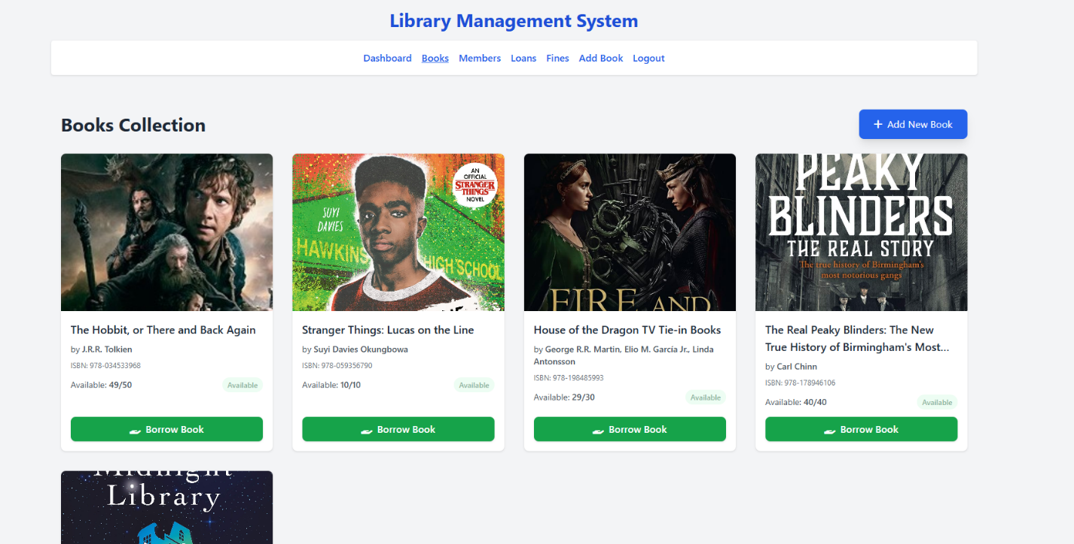

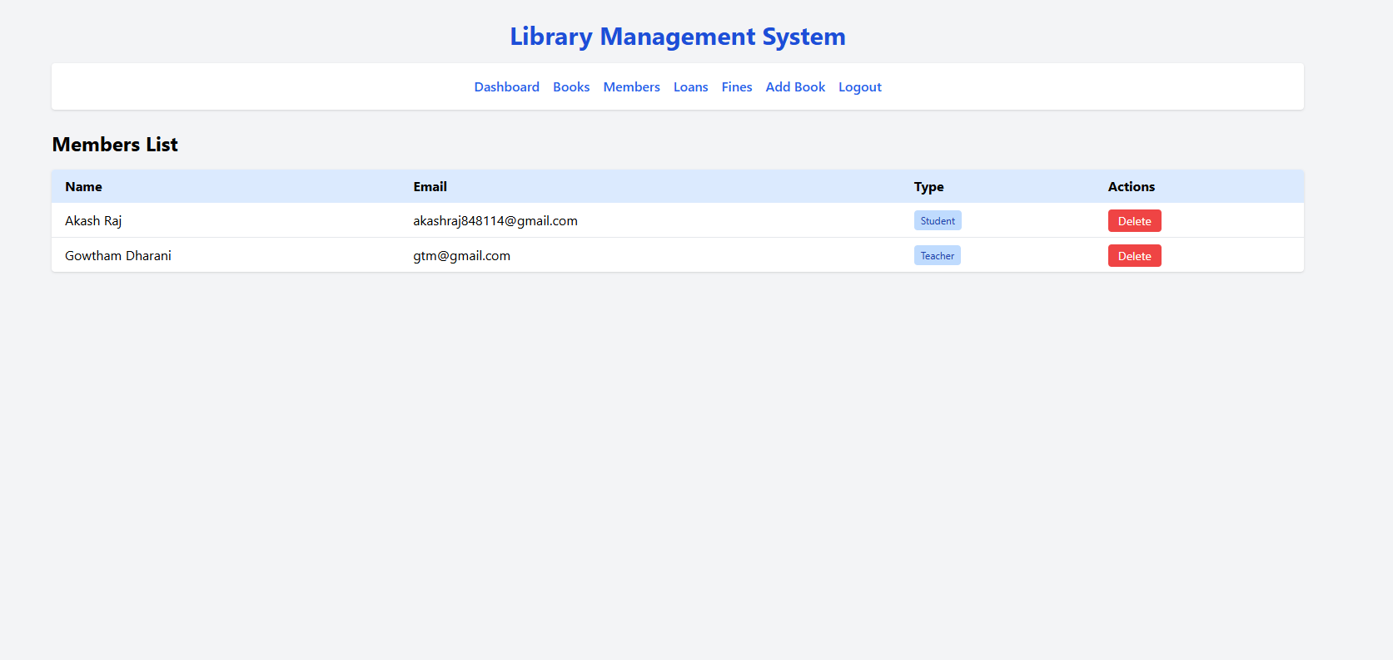

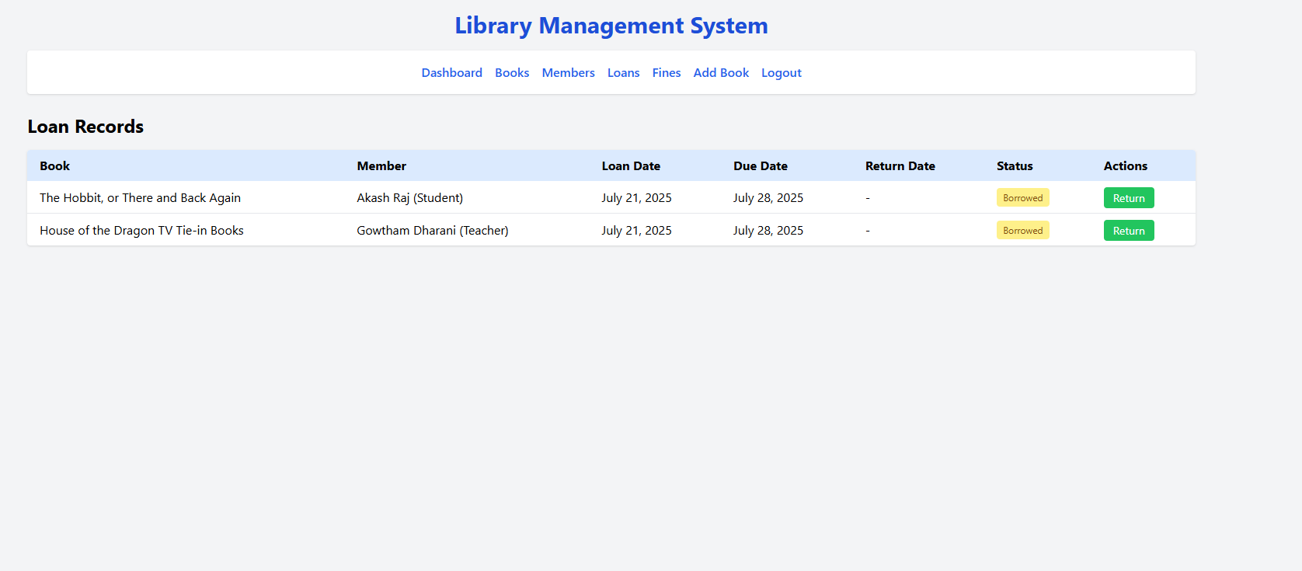

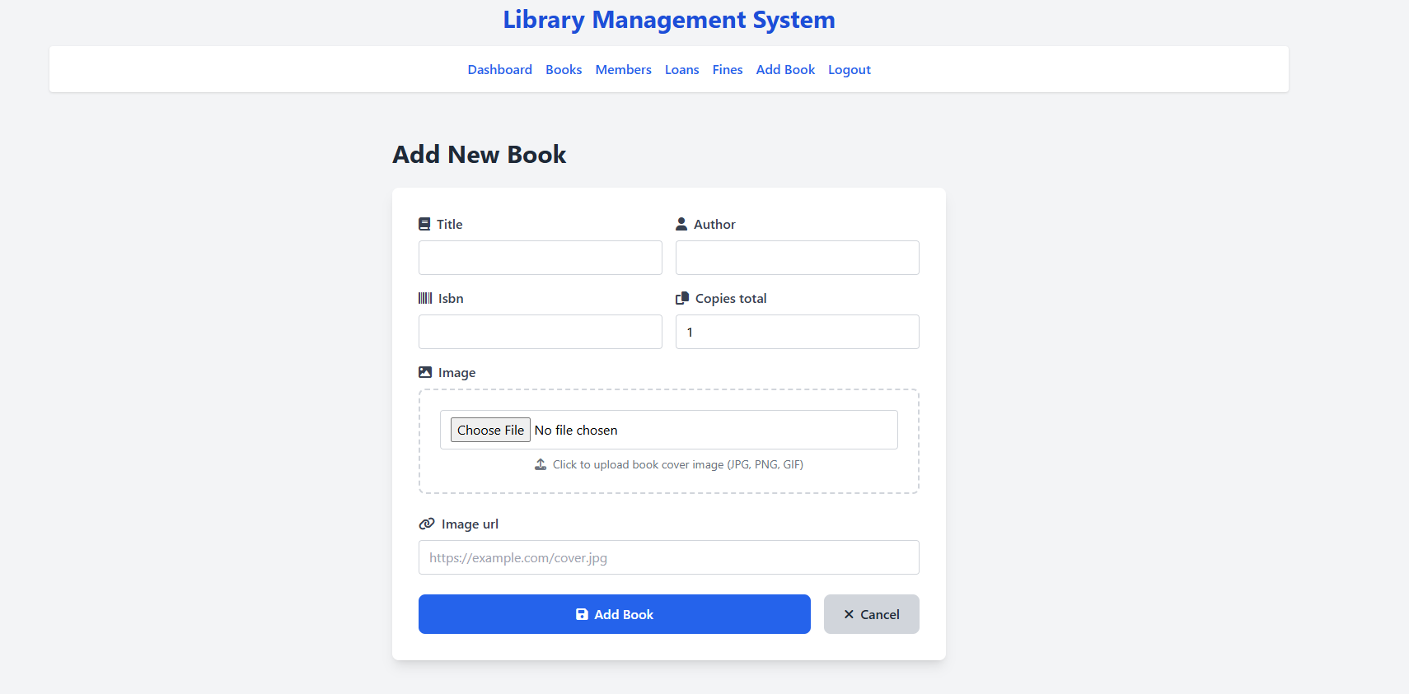

**Visit : https://lms-tn6r.onrender.com/login/**